----------------------------------------------------- HOURS

Team Member  First Last | Hours  this Week | Total Hours  since Aug 19 | Signature  you verify that hours of all team members are reported truthfully
Trace Shafer | 7 | 169.5 | Trace Shafer
Ben Sherman | 7 | 173.5 | Ben Sherman

----------------------------------------------------- TIMELINE
Design Review | Expected Presentation Date | Status | Completion Date
Conceptual Design Review | 9/4/2024 | COMPLETED | 9/4/2024
Preliminary Design Review | 11/8/2024 | COMPLETED | 11/8/2024
Critical Design Review | 12/9/2024 | COMPLETED | 12/9/2024
Test Readiness Review | 2/14/2025 | IN PROGRESS
Test Results Review
Improvement Review
Final Review
Exhibition

----------------------------------------------------- ACTION REPORT

Team Member  First Last | Action Report  List actions taken this week towards your in-progress review. Give details using Research & Analyze, Design, Prototype, Test, and Report.
Trace Shafer | Research and Analyze  - Got different dot pictures ready to print for the star tracker camera calibration  - Met with Professor Schiller about ordering tools that we are going to need to machine the reaction wheel mounts.  Prototype  - Printed out the reaction wheel mount that we will use for testing.  - Printed out other components that will be used for testing.
Ben Sherman | Research & Analyze  - Looked into quaternion to Euler angles to Modified Rodrigues Parameters.  - Looked into different options to use air bearing  - https://www.thingiverse.com/thing:3945918  - Worked on implementing Dr Eves suggestions to the code  Report  - Working on getting code done to finish Delta CDR  - Working on test readiness review

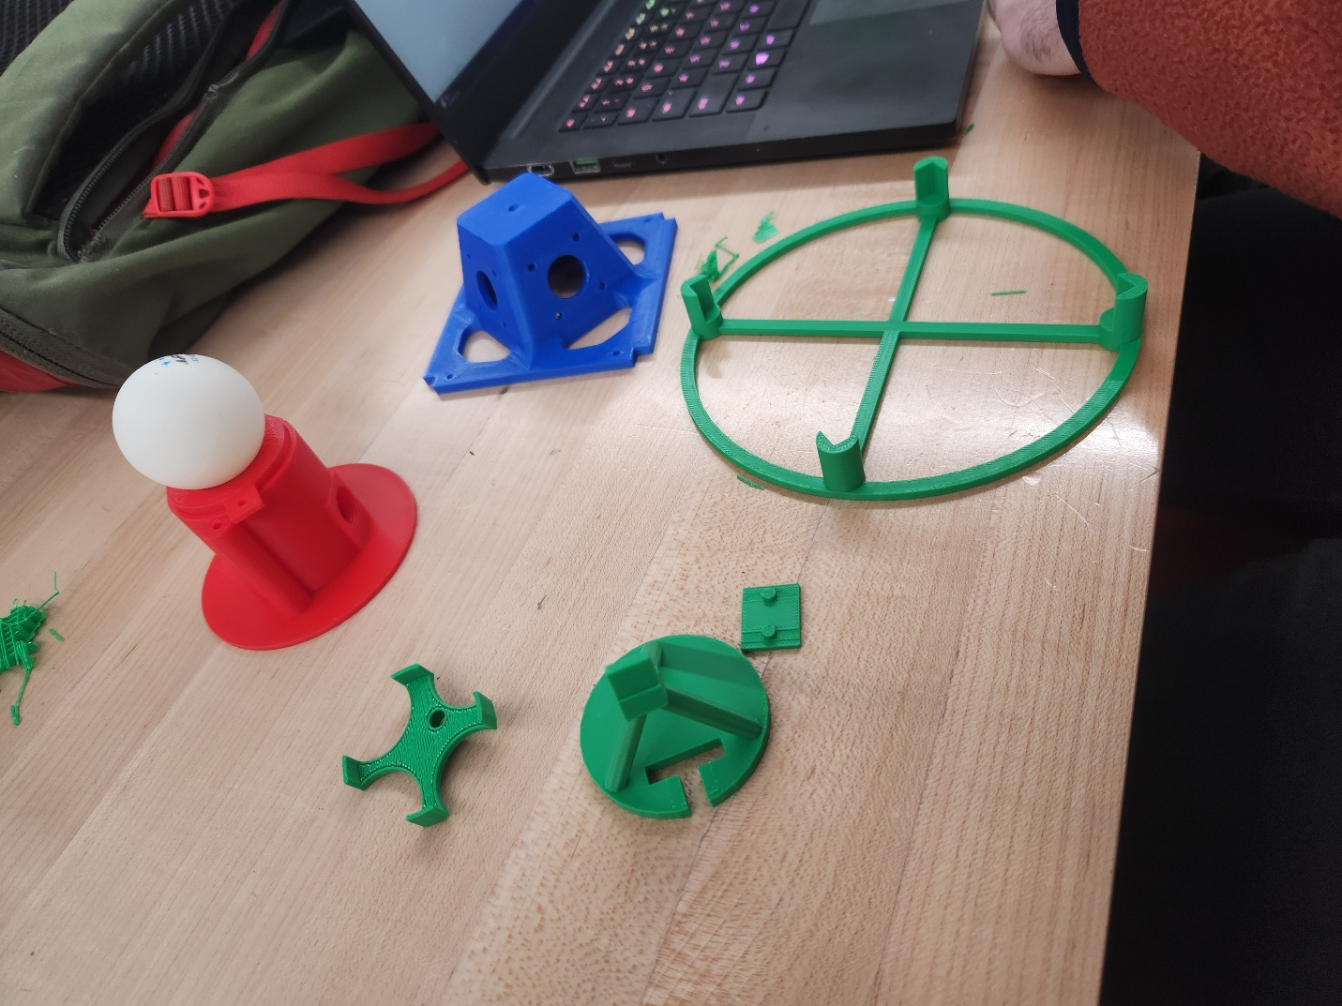
----------------------------------------------------- ACTION PLAN

Team Member  First Last | Action Plan  List actions you plan to take this week towards your reviews. Give details using Research & Analyze, Design, Prototype, Test, and Report.
Trace Shafer | Research & Analyze  - Continue to work on the simulation implementing the changes suggested by Dr. Eves since we did not get to meet last week.  - Print out the camera calibration pictures at the library.  Prototype  - Print out the rest of the testing components  Report  - Go over the slides again for Test Readiness Review  - Work on Delta CDR
Ben Sherman | Research & Analyze  - Improve the code we are using, make sure LQR is working properly and then add EKF  Test  - Design and 3D print test fixtures  - Finish getting air bearing fixture ready  Report  - Continue working on Test Readiness Review

